English :

Your CMS Dealer is evolving; discover two new features.

1. New procedure for claiming promotional refunds.

Starting today, you can use our new online claims system.

By claiming your refunds online, you will:
- Quickly view all eligible promotions for claiming.
- Claim your promotions throughout the season.
- Receive your refunds on a monthly basis.

To access it, go to your CMS dealer and click on "Make a Claim"

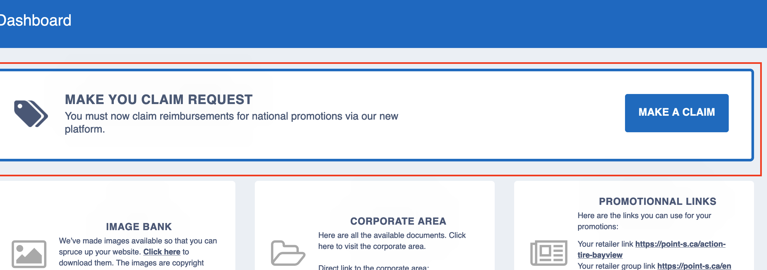

Next, select a promotion.
Note: Only claimable promotions are displayed in the list. 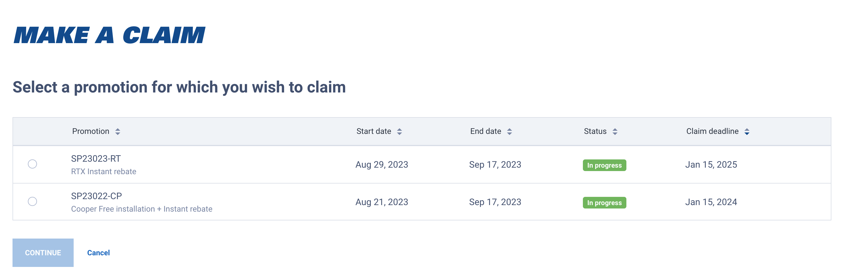
Then, fill in all the information on the form and attach your invoices to complete the claim.

2. Customize your tire installation prices for online sales.

Now, you have the option to choose your pricing policy for tire installations.

Go to your CMS dealer in the Price and services section (ajouter le lien: https://dealers.otobox/services/)

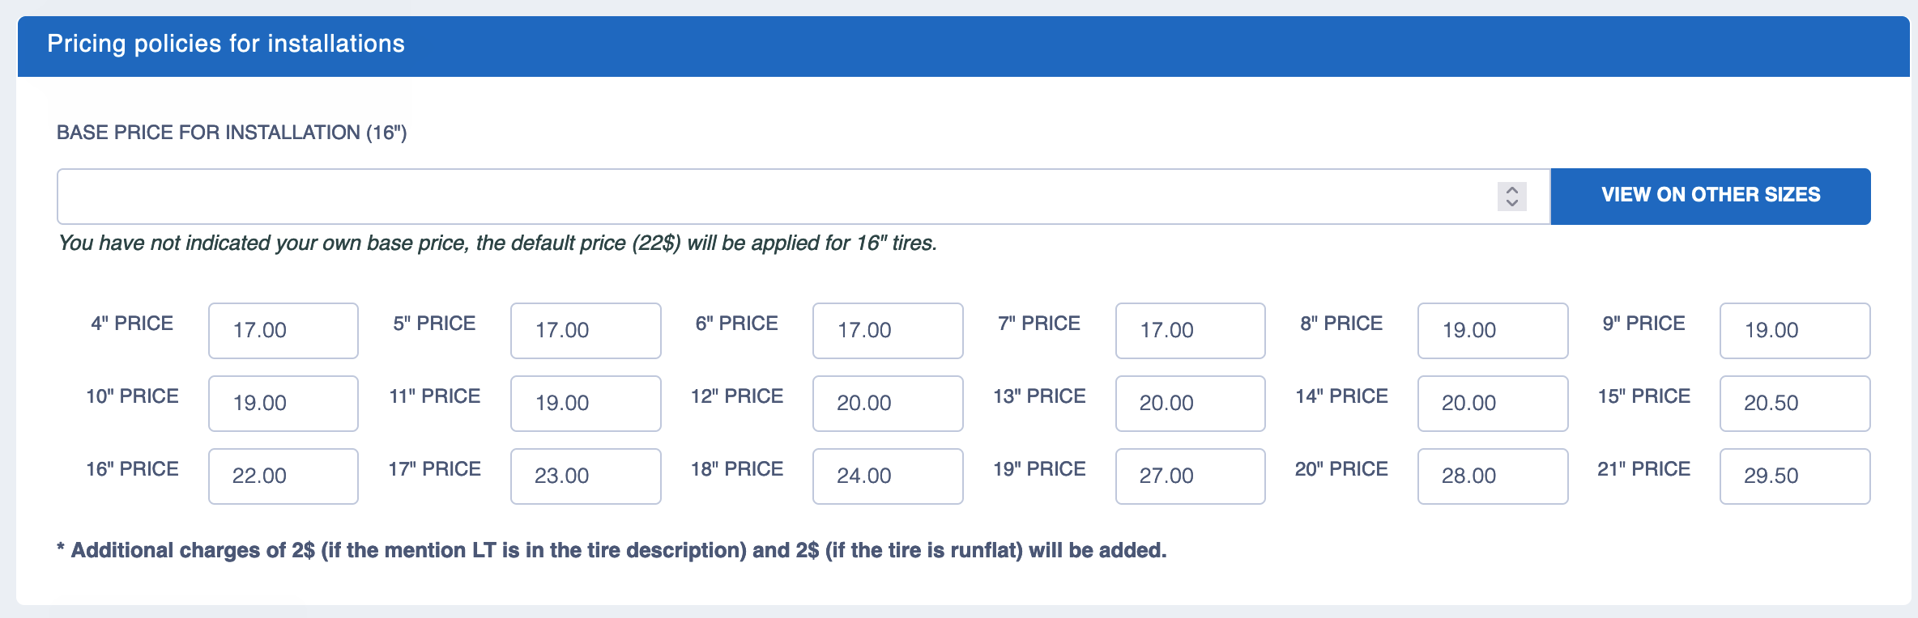

By default, the price is set at $22.
To change your price, you need to enter the base price for the installation of a 16" tire not mounted on alloy wheels.
Then click on "View on other sizes" to see the effect of your customization.
Don't forget to save the change.

